Service Records Checklist

2020-2021 School Year

Presented by ESC, Region 14

2020

Complete Service Records after June Payroll.

TxEIS Service Records Checklist
TxEIS will retain data on multiple years of service and accumulated state leave(s.) The Extract Teacher Service Record page is typically used in June to extract stored employee data and create a service record. The service record detail can then be accessed by school year from HR > Maintenance > Staff Demo > Service Record tab. When an employee leaves the district, a service record can easily be printed, signed, and sent with the employee or forwarded to the employing district.

Warning: Service records must be extracted before new contract information is entered in Current Payroll or rolled in from Next Year Payroll and prior to updating the Years’ Experience fields in Maintenance > Staff Job/Pay Data > Employment Info tab. It is recommended that service records be extracted for ALL employees after June payrolls have been completed. If all leave for the current year has not been posted, the option “Update Leave Only” on the service record extract screen may be used after leave is posted in July and August for those employees.

_____1. Verify the State Leave codes. From Tables > District HR Options table, verify the codes used by your district for the old State Sick Leave program and the Current State Personal Leave program are indicated.
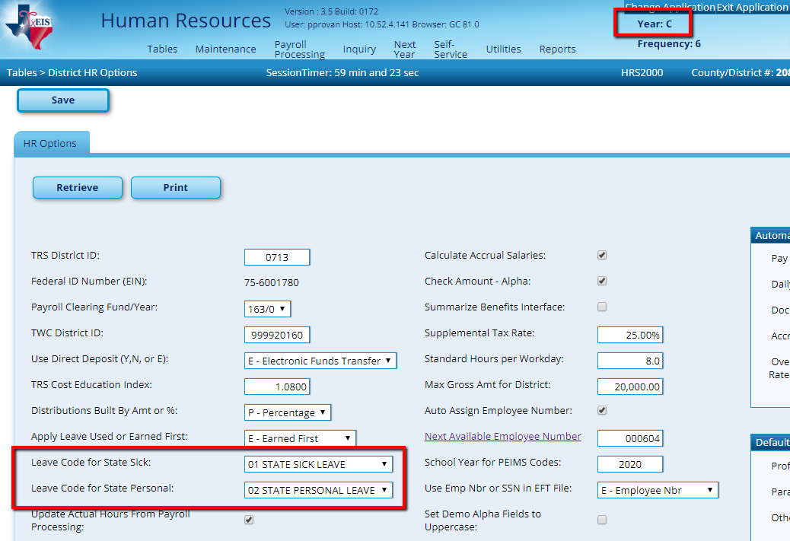

_____2. Verify employee data is correct. The easiest way to verify is through a User Created Report. Run a report from Reports > User Created Reports>HR Report, selecting the following data elements:
- Years Non Professional Experience
- Job Description
- Contract Begin Date
- Contract End Date
- Number of Days Employed

- Active Employees Only
- Employee Nbr
- First Name
- Last Name
- Percent of Day Employed
- Years Professional Experience
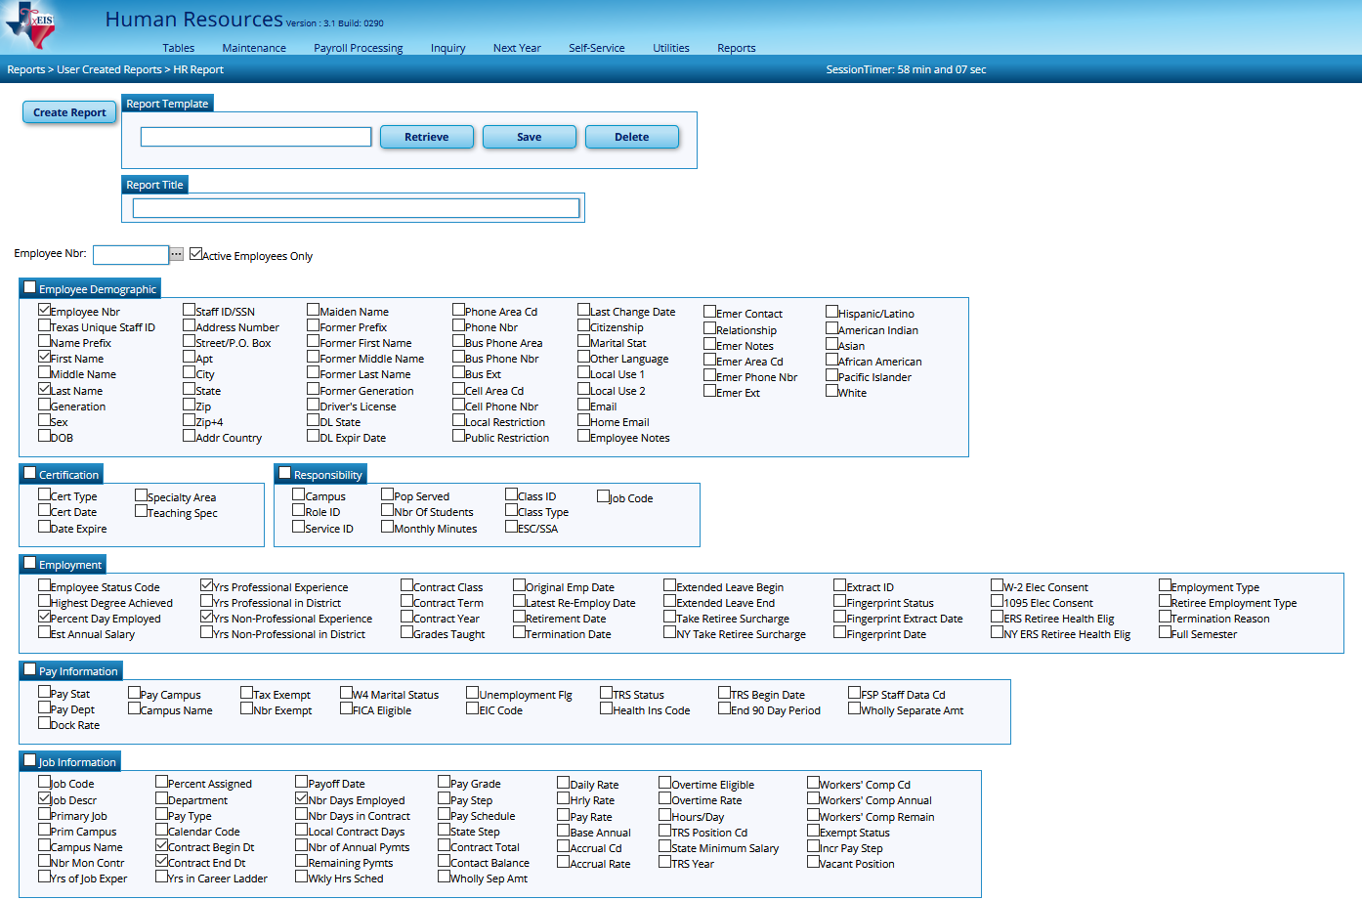
The sort/filter options may make it easier to verify data.

Note: By pulling the report to only include Active employees, you may miss employees who left your district early. If so, be sure to verify information on those employees individually.
Verify the following:
- Percent Day Employed – most will be 100% (1.0 on report). Watch for employees that are marked less than 100% and for those who should be less than 100%.
- Years’ Experience – most will have either professional years or non-professional years. It is possible someone started as a non-professional such as an aide and then became a professional and would therefore have years’ experience in both categories, but it won’t happen very often.
- Job Description – pulls from Job Info screen. If employee has multiple jobs, all should pull. However, if they changed jobs and you removed the old job in the job info screen, you may need to manually add the information for the old job.
- Nbr of days Employed – verify accuracy. Watch for those who started late or left early to ensure accuracy.
_____3. Review Service Record Notes. From Tables > Credential > Service Record Notes, review and modify table as desired – table is user-defined. This note area is intended to help the district to record information that is pertinent to specific service years.
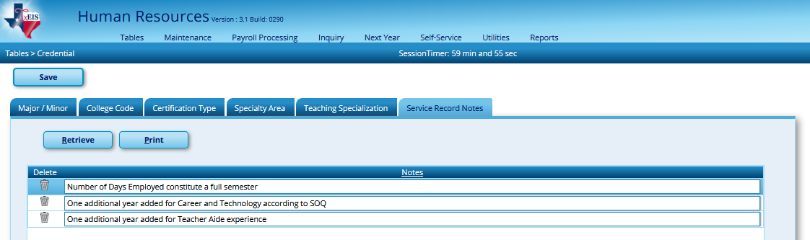
_____4. Make a backup of Payroll. From Utilities > Extract Human Resources by Payroll, select all payroll frequencies and pull to the right. Execute and save all backups in the Service Records folder.
Note: There will be a file for each payroll frequency.
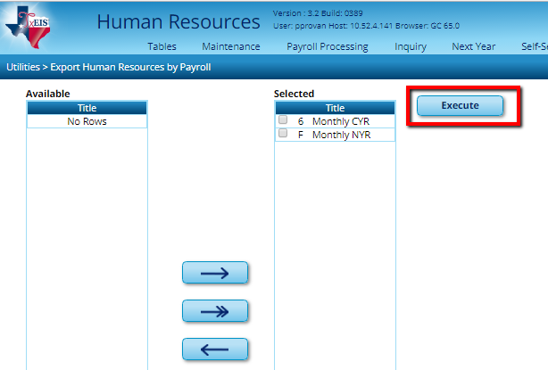
_____5. Enter Extract criteria.
Utilities > Extract Teacher Service Record,
- School Year – Defaults to current school year from Finance District Options screen.
- Frequency – System selects frequencies authorized for use by the User.
- Pay Type - Typically, Enter Pay Type 1, 2, & 3 excluding Pay Type 4 for Substitutes. If *1, 2 & 3 is not entered and this is left blank then all employees will pull including sub’s.
Note: If a sub is a certified teacher and they substitute at least 90 days, it is possible for them to earn a year of service credit. Since all work is combined, it is recommended that those subs receive a service record.
- Enter other criteria if needed. Example: Employee Nbr.
- Enter either Contract Begin Dates or Payoff Dates for this school year.

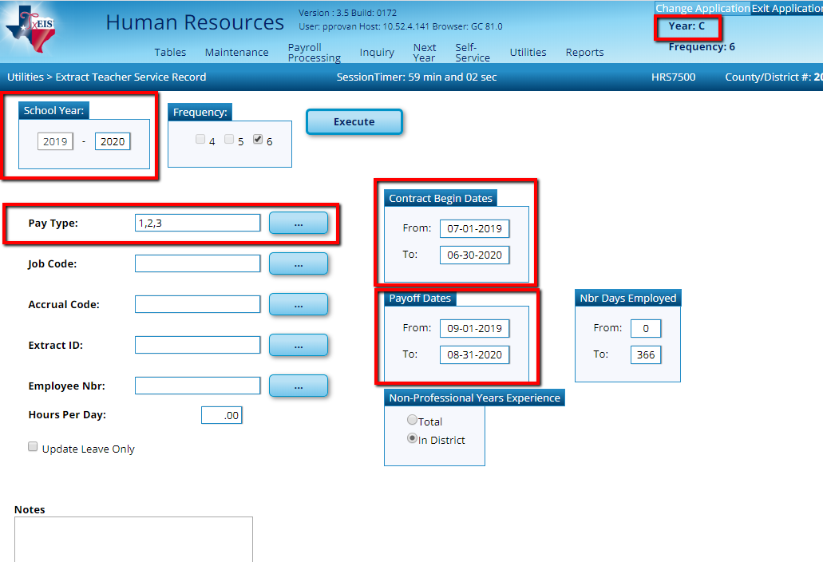
Use ONE of these to ensure correct information is extracted.

Use these if you want to limit the employees you’re extracting.
Pre-set note entered in Tables > Credential > Service Record Notes will appear when user begins to type.
- Nbr Days Employed - allows User to enter a range in the from and to number of days to limit employee selection. Typing the fewest and greatest number of days employed from the Job Info tab extracts records for all employees within that range (e.g., 001-365). The system pulls from the # of Days Empld field on the Staff Job/Pay, Job Info screen and does not take into consideration the Serv Rec Days Ded field on the Leave Adjustment, Abs Ded, or Cd Abs Ded tabs. Usually this field is left blank unless the desired extract requires them.
- Non-Professional Years’ Experience – select whether you want to display Total Year of Experience or only Experience In District for Non-Professional staff (TRS Member Positions 03 and 04.)
- Once the parameters are selected, click Execute.

_____6. Delete employees you don’t want to extract Service Records on and Continue. When you execute, a list of employees meeting the criteria selected they will display. Any employees who has a service record extracted for this year already will have 2 or more lines, one of which will be highlighted in blue. The blue line represents the initial extract. Review all lines for that employee to determine which should be permanently written to the service record. Select Delete for rows that you do not want.
Example 1: Lauren Bacall was initially extracted with 186.00 days employed. The new line shows 163 days employed. If the original (186 days) line is correct select Delete for the new line. If the New Line (163 days) is correct select delete for the blue line.
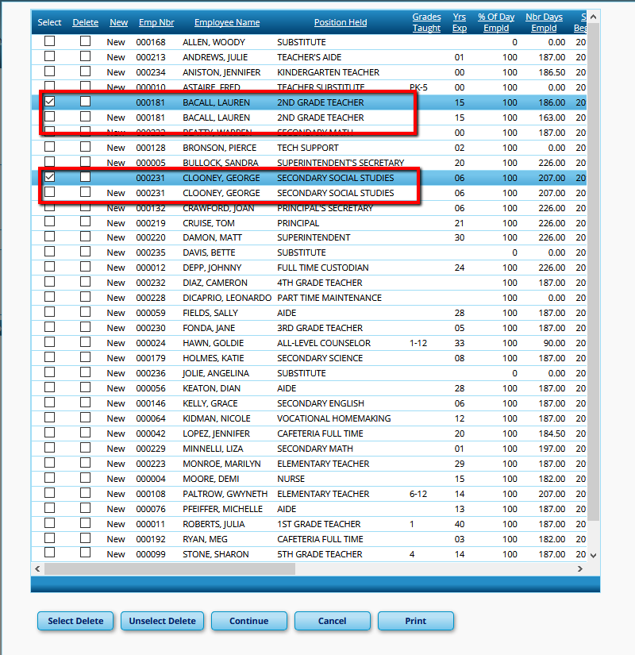
Example 2: George Clooney has update leave information. (Must scroll to the right to see). Again choose which line should be deleted.
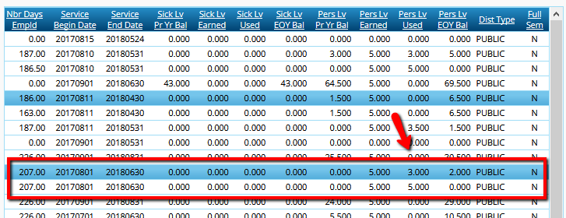
Once the selections have been made click Continue at the bottom of the screen to get your preview.
At the preview, review the list to ensure it includes only those employees you wish to extract and Process.
_____7. Review and edit as needed. All necessary information is now stored and can be reviewed at Maintenance > Staff Demo > Service Record tab. Click on the spyglass beside the school year you wish to review and/or edit. The information for that school year will be displayed below. Edit as desired and Save changes.
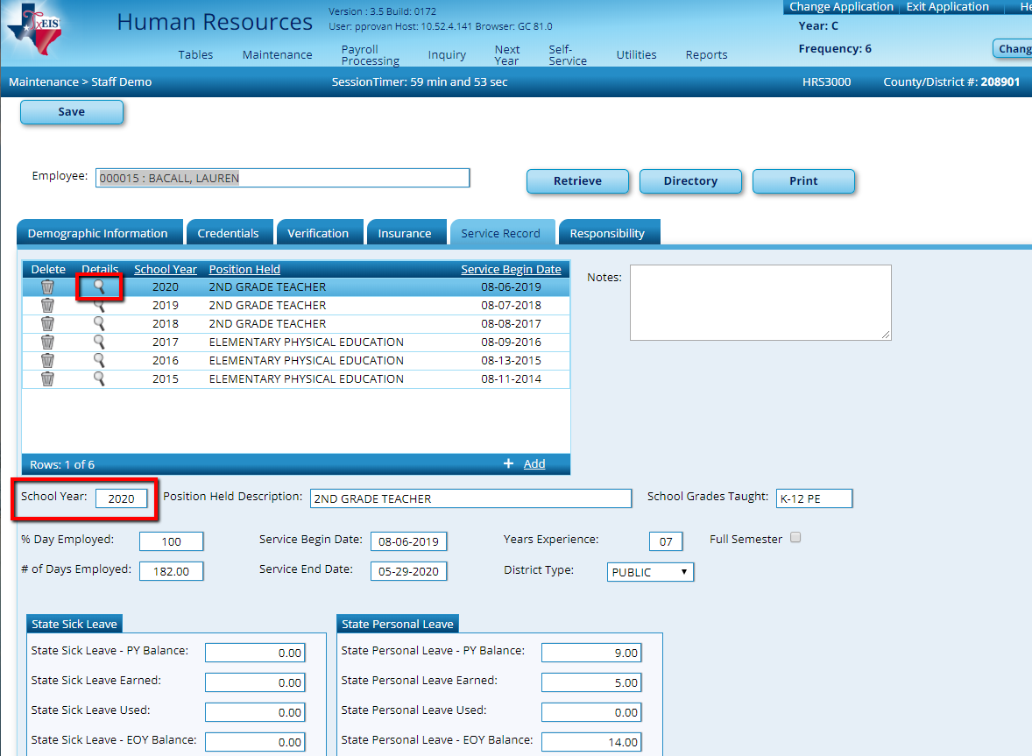

Other Considerations
- If employees were docked through the leave system, adjustments will be displayed in
Maintenance > Leave Account Transaction > Leave Adjustment Tab.
TxEIS will calculate the days to put on the service record by subtracting any days listed in the Serv Rec Days Ded column from the number of days employed on the Job Info screen.

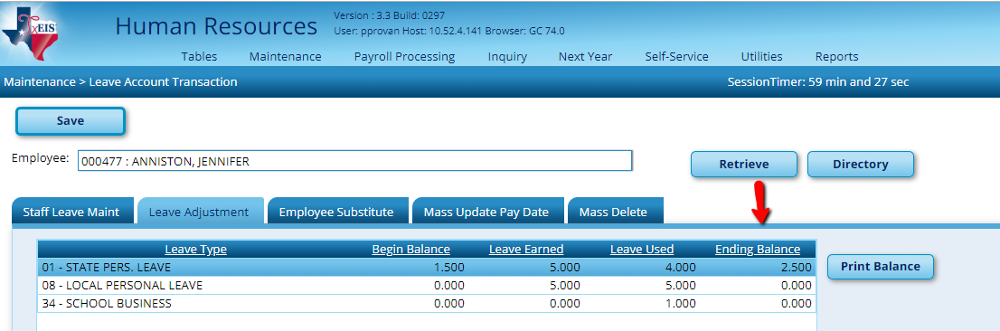

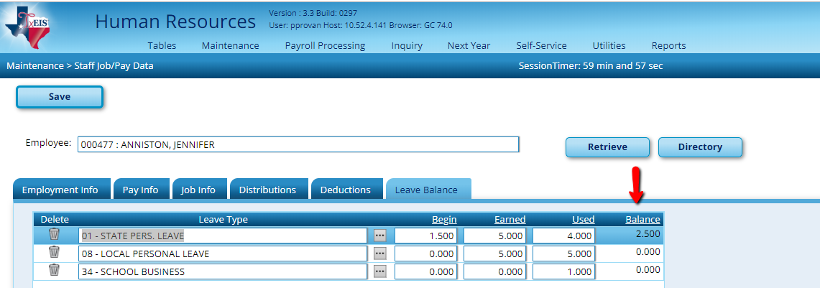
- If errors exist that prevents a Service Record from being created during the extract process, then a “Records Not Created” report will display. You will have the choice to CANCEL and correct or, if errors are acceptable you will have the option to CONTINUE. If CONTINUE is chosen, then these employees will not have a Service Record created with this extract.
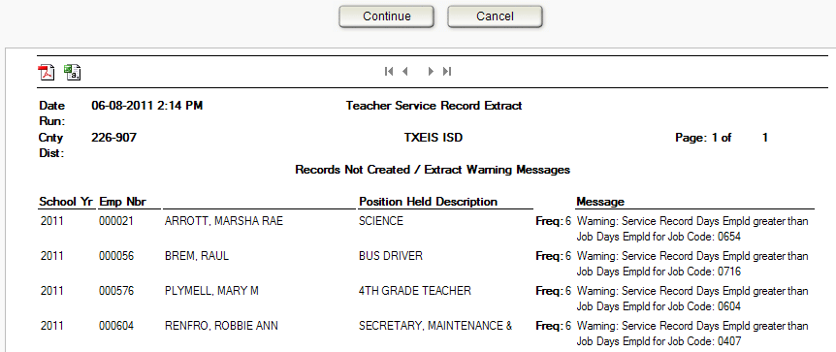
Bullock, Sandra
If there are no employees to match the extract criteria, then no service record will be created and the system will issue the following message: “No Service Data Extracted.”
- If needed add Service Record Notes to Individual Employees.
Maintenance > Staff Demo > Service Record Tab
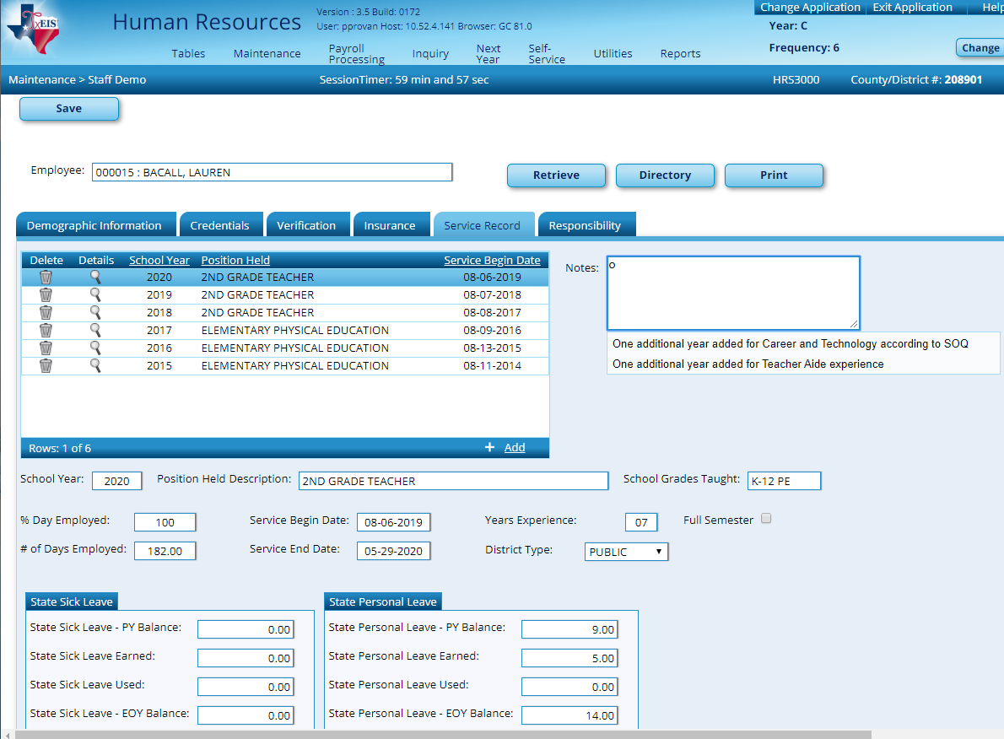

- You should always scroll down to look for duplicates when you get the Data Preview screen. If you see an employee listed more than once for the same ‘Position Held’, you will need to choose which extract to delete for that employee. “NEW” is the current extract and the other line(s) are from a previous extract for that employee. Duplicate Service Records will be created if no deletion is chosen.

- If an employee has changed jobs during the year and is no longer being paid for the original job, both jobs should remain on the Job Info screen. The % Assigned field requires at least 1% in the original job for it to remain available on the Job Info screen and the new job should be marked as Primary. When the extract is performed, both jobs will be extracted for the Service Record and you will not need to manually add any job information for the original job.
- If the employee has changed jobs during the year and the original job no longer displays on the Job Info screen, you must manually add the original job to the Service Record maintenance screen found under the Staff Demo screen.
- If an employee has multiple jobs, all jobs will be extracted. Always review the extracted information and perform maintenance if invalid information exists.
- In the Service Record Maintenance screen check accuracy of:
- Begin and End Dates for each Job
- # Days Employed for each Job
- State Leave amounts and if the balances flow from year to year.

Updating Leave After Service Record Extract
If leave is taken after you have completed the Service Record Extract, you may update those balances from Utilities > Extract Teacher Service Record. Select the criteria for the employees you wish to update and check the Update Leave Only box.
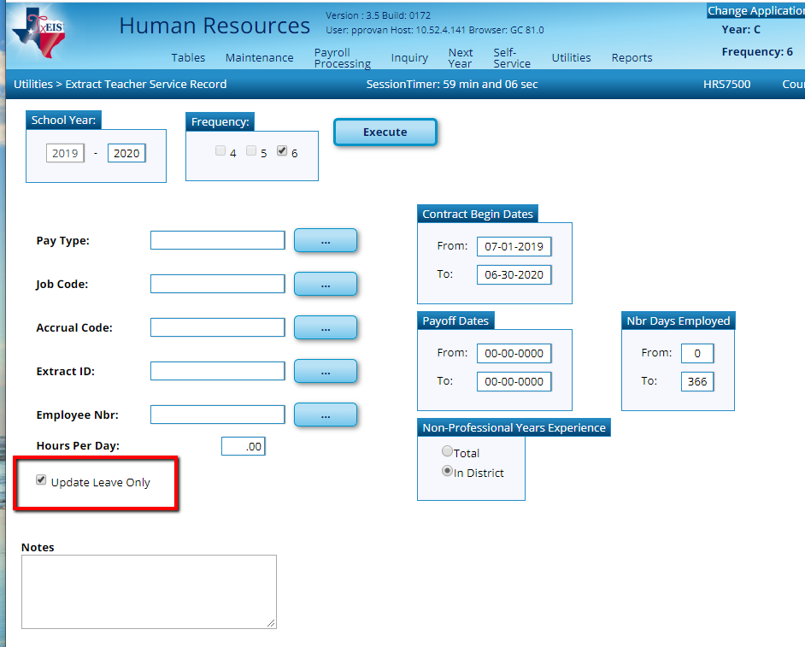

Previews will alert you to which records will not be updated for leave balances as well as which records will be updated. Review for accuracy. Cancel and make corrections if needed, or Continue and Process to update the leave balances.
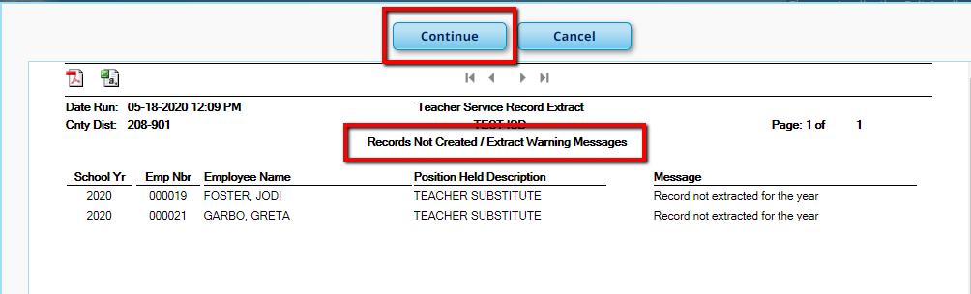
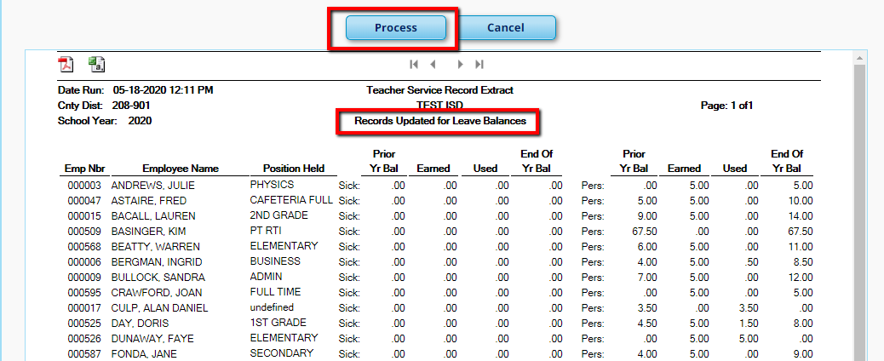

Printing the Service Record
An Official Service Record is available upon the employees’ request. To print a Service Record, go to Reports > HR Reports > Personnel Reports > Teacher Service Record (HRS1400).
Re-verify all information. This is the Official Teacher Service Record and must be signed by the employee and the district personnel authorized to sign off on Service Records. Convert to pdf to print.

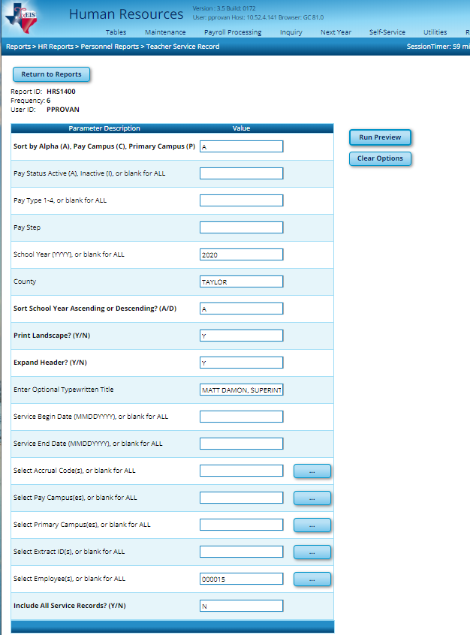
If you need to print all records enter a ‘Y” for the Include all Service Records. You will not enter Employee number(s).

If you need to print only certain Employees, you will enter the Employees number(s) then enter ‘N’ for the Include all Service Records.
This will print under the Authorized Signature line on the Service Records

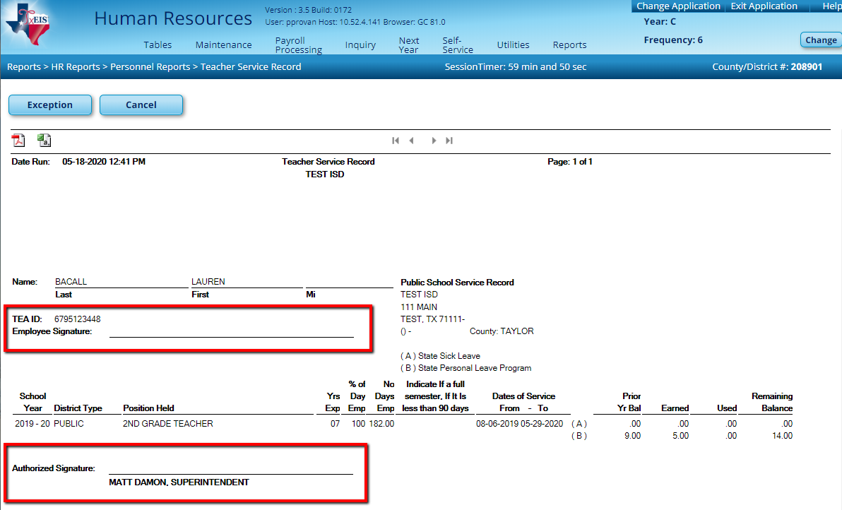

You are not required to print a service record for every employee every year. However, you must be able to produce a complete record of service at your district upon employee request and/or when the employee leaves the district. The process of successfully extracting service records stores a Service Record in the employee’s file in TxEIS for future availability.

How are Years of Service Determined?
According to the instructions for completing a teacher service record, you should record actual experiences by Sept 1 of the school year. This means the current school year is not included in the total years of service.
Example 1:
John graduated in 2019. He came to work at your district in August 2019. As of Sept 1, 2019 he has not yet completed a year of service so his record will indicate ‘0’ year experience for 2019-2020.

Example 2:
Amy was a certified teacher’s aide in 2011-2012, 2012-2013, 2013-2014. She then got her degree and teaching certificate and began as a teacher during the years of service, Section 53. 1021, Section M says that Amy can receive up to 2 years of creditable service applied for salary increment purposes. So Amy should show 8 years’ experience (2012= 0, 2013 = 1, 2014 = 2, 2015 = 3….2020 = 8) she should be on step 7 for salary purposes (only 2 years’ credit for aide job, not 3) for 2020. She will be on step 9 for 2020-2021, We recommend adding a note indicating she was given 2 years’ credit for salary increment purposes and therefore was paid on Step 7 for 2020.
Where is Service Record information extracted from within the system?
Service Record Field | System Data Fields | Screen
School Year | The Current School Year from Finance District Options and all previous years that the employee has worked for the District | Finance – District Finance Options Table
Position Held Description | Employee's Job Code | Job Info
School Grades Taught | Grade(s) Taught | Employment Info
Years Experience | TRS Member Position Code  If: 01(Professional) - Prof Years Exp Total  02(Teacher,Librarian) - Prof Years Exp Total  05(Nurse,Counselor) - Prof Years Exp Total  03(Support Staff) - Years Exp in District  04(Bus Drivers) - Years Exp in District | Employment Info  Employment Info  Employment Info  Employment Info  Employment Info
% Day Employed | Percent Day Employed | Employment Info
# of Days Employed | Calendar Info box - # of Days Empld minus Leave Serv Rec Days Ded | Job Info  Leave Acct Trans>Adj
Service Begin and End Dates | Calendar Info box - Begin Date, End Date | Job Info
Notes | Extract parameter or Maintenance>Staff Demo | Extract or Staff Demo
State Sick Leave | State Sick Leave (Old) | Leave Balance
State Personal Leave | State Personal Leave (Current) | Leave Balance

